Faculty and Students Achievements in 2025-26
- Awards

- Hackathons

- NPTEL- Gold/Silver/Elite

- Best paper Award

- Sports, Debate etc

Faculty Achievement (2025-2026)

Name of Faculty | Achievement
Prof. Anand Godbole | NPTEL Discipline Star Award
Dr. Pramod Bide | Best Innovative Teaching Award by L&T Edutech
Dr. Jignesh Sisodia | Best Software Project Award by Cantilever
Prof. Govind Gaundalkar | Best Question Paper Award,  for the subject Digital Systems
Dr. Jignesh Sisodia,  Prof. Abhijit Salunke | Best Question Paper Award,  for the subject Computer Communication and Networks
Prof. Anand Godbole | Elite NPTEL Certification - Joy of Computing using Python
Prof. Anand Godbole | Elite NPTEL Certification - Theory of Computation
Dr. Jignesh Sisodia | Elite NPTEL Certification - Computer Architecture
Prof. Reeta Koshy | Elite NPTEL Certification - Software Engineering
Prof. Sunil Ghane | NPTEL Certification - Theory of Computation
Prof. Swapnali Kurhade | Elite NPTEL Certification -AI in Industrial & Management Engineering
Dr. Surekha Dholay | Reviewer in Technical Program Committee

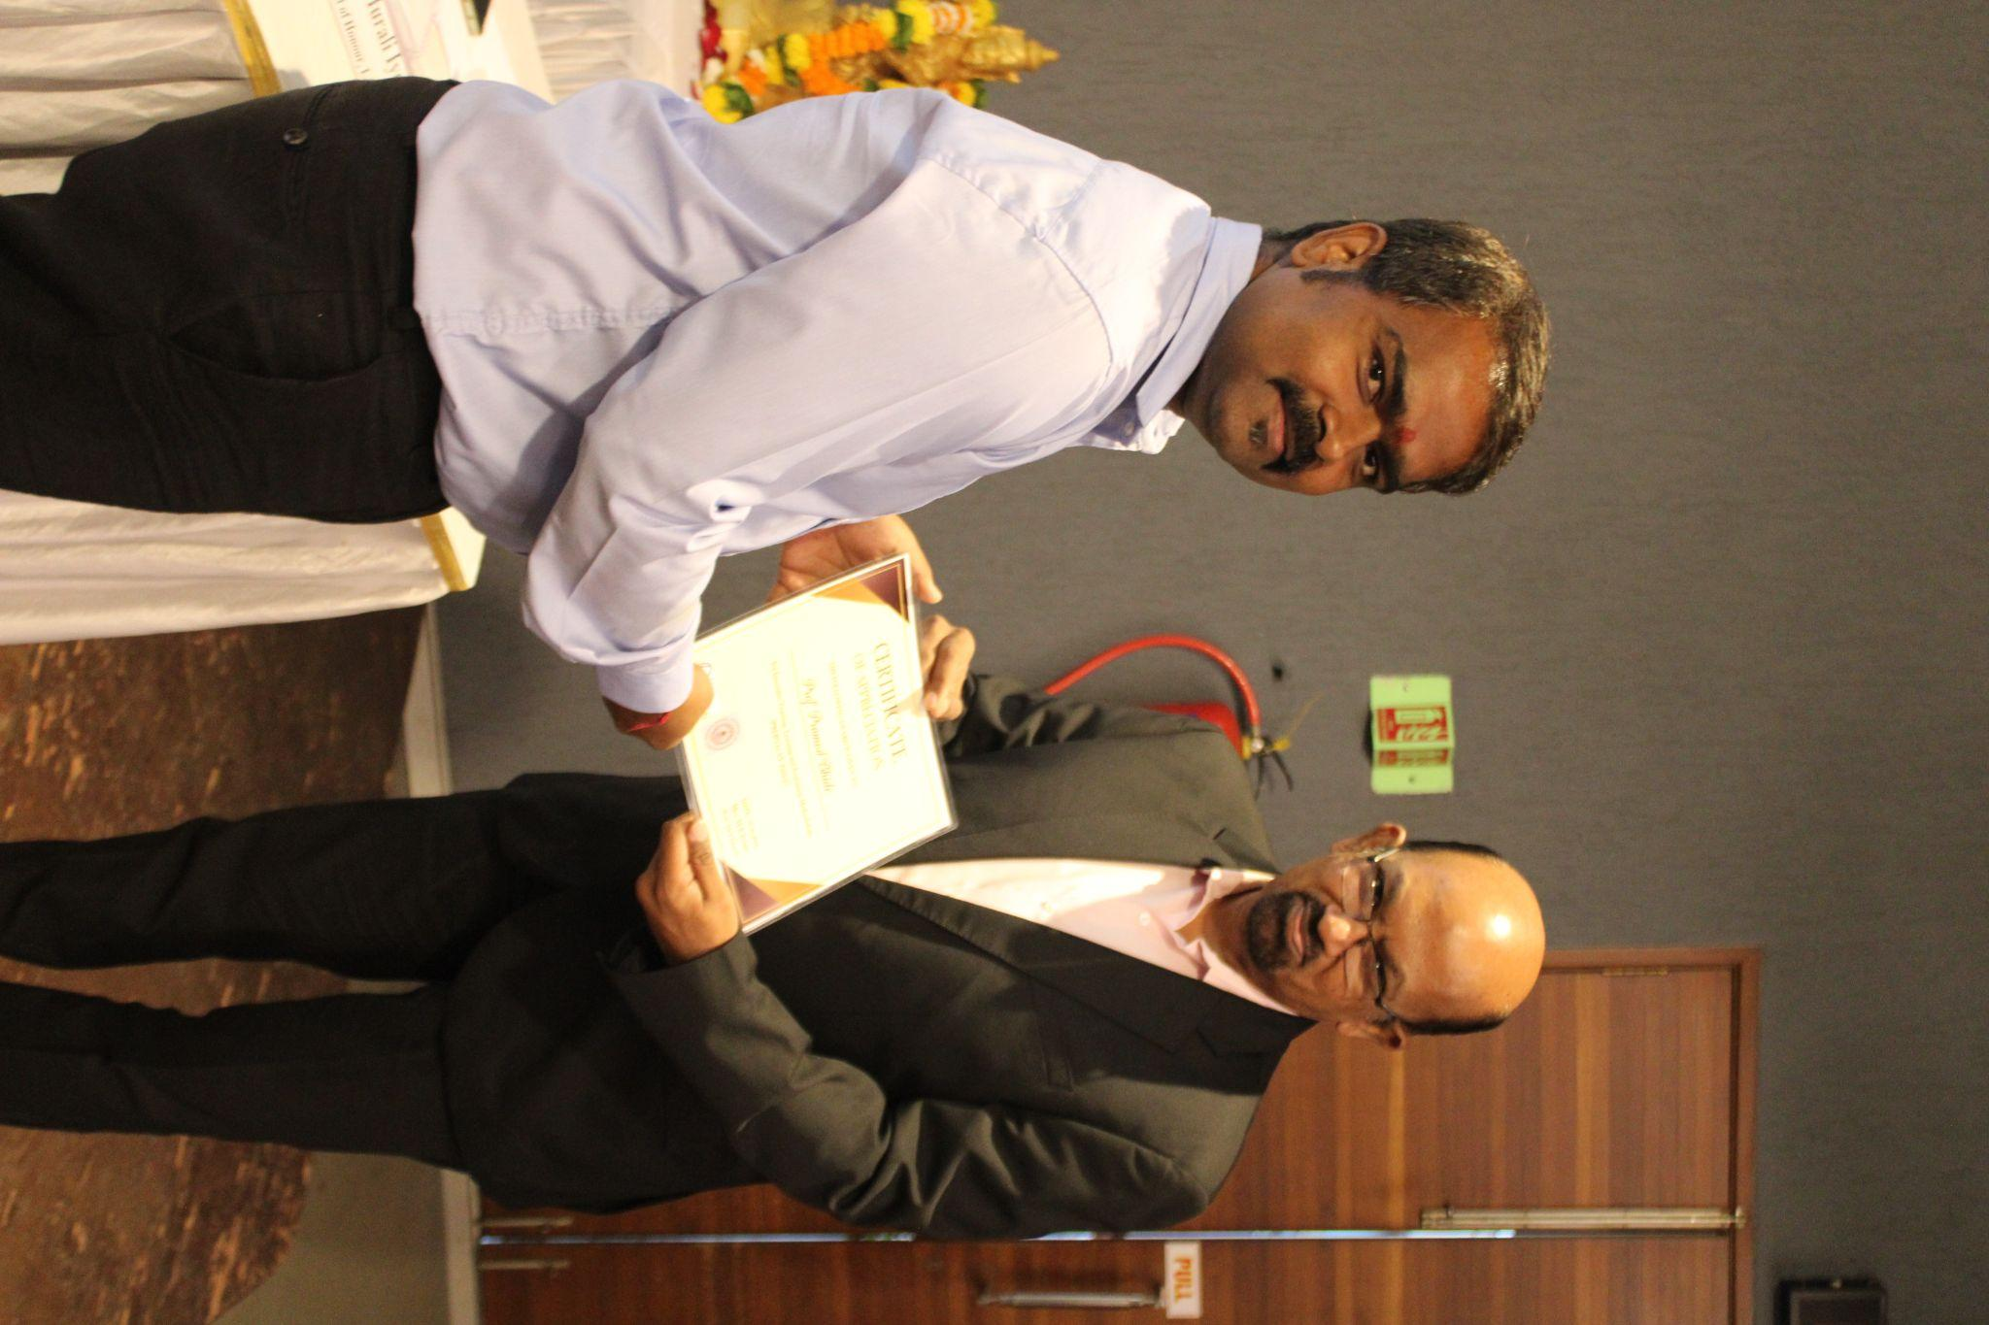
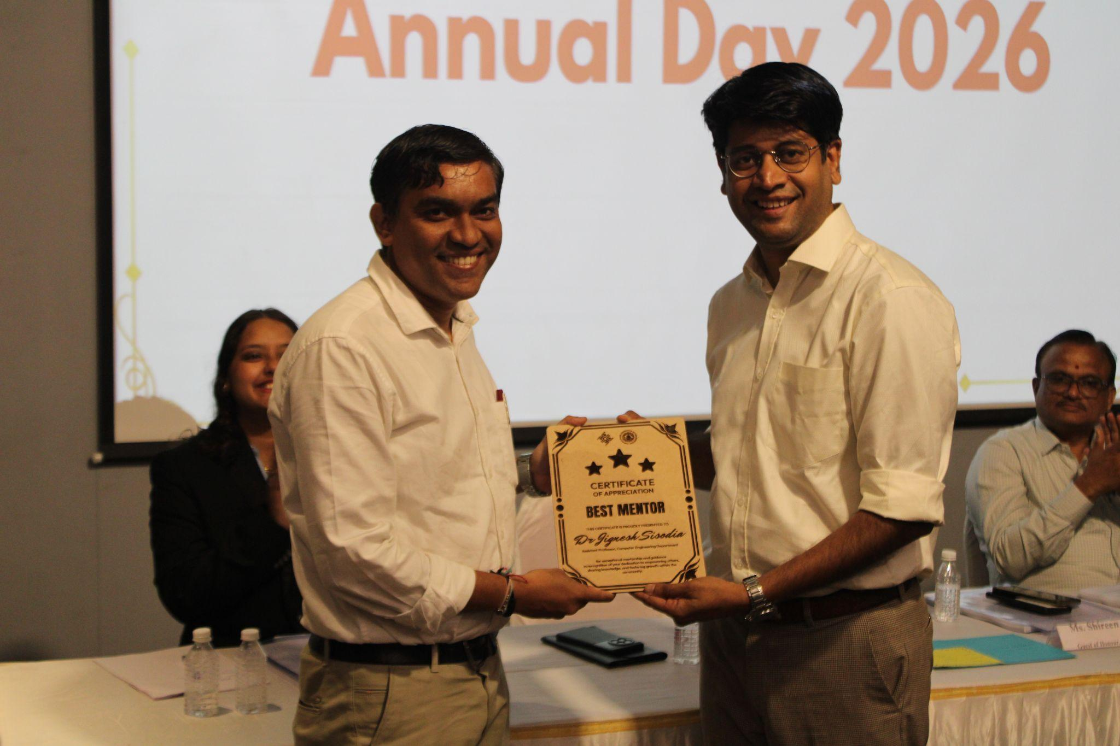
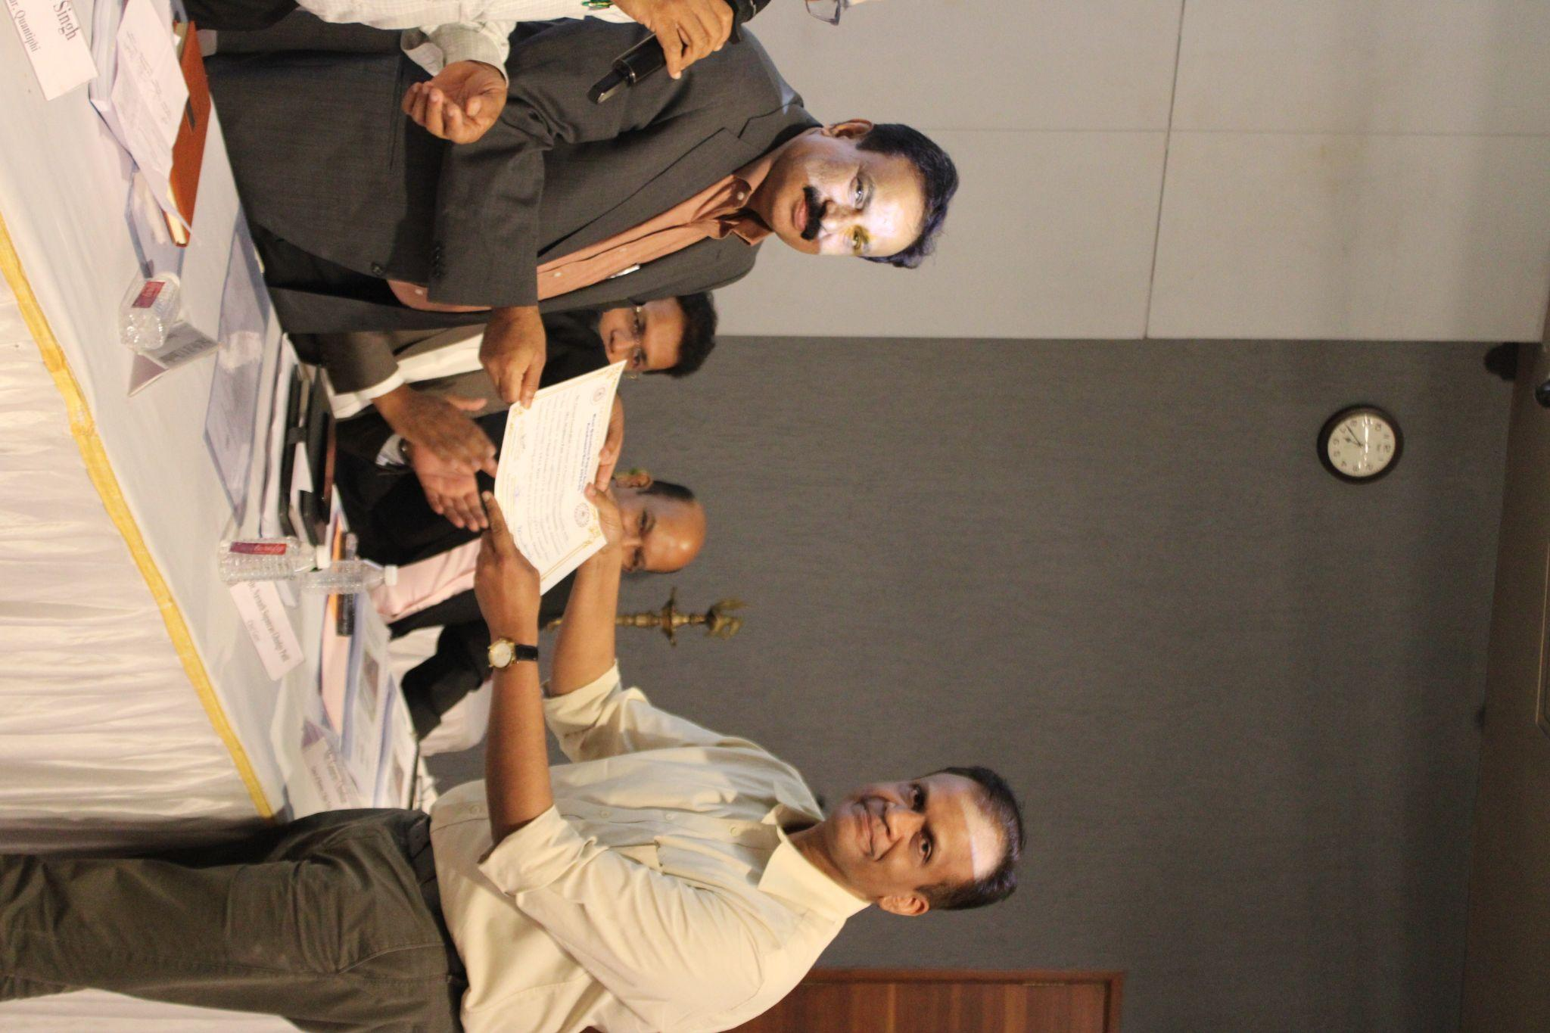
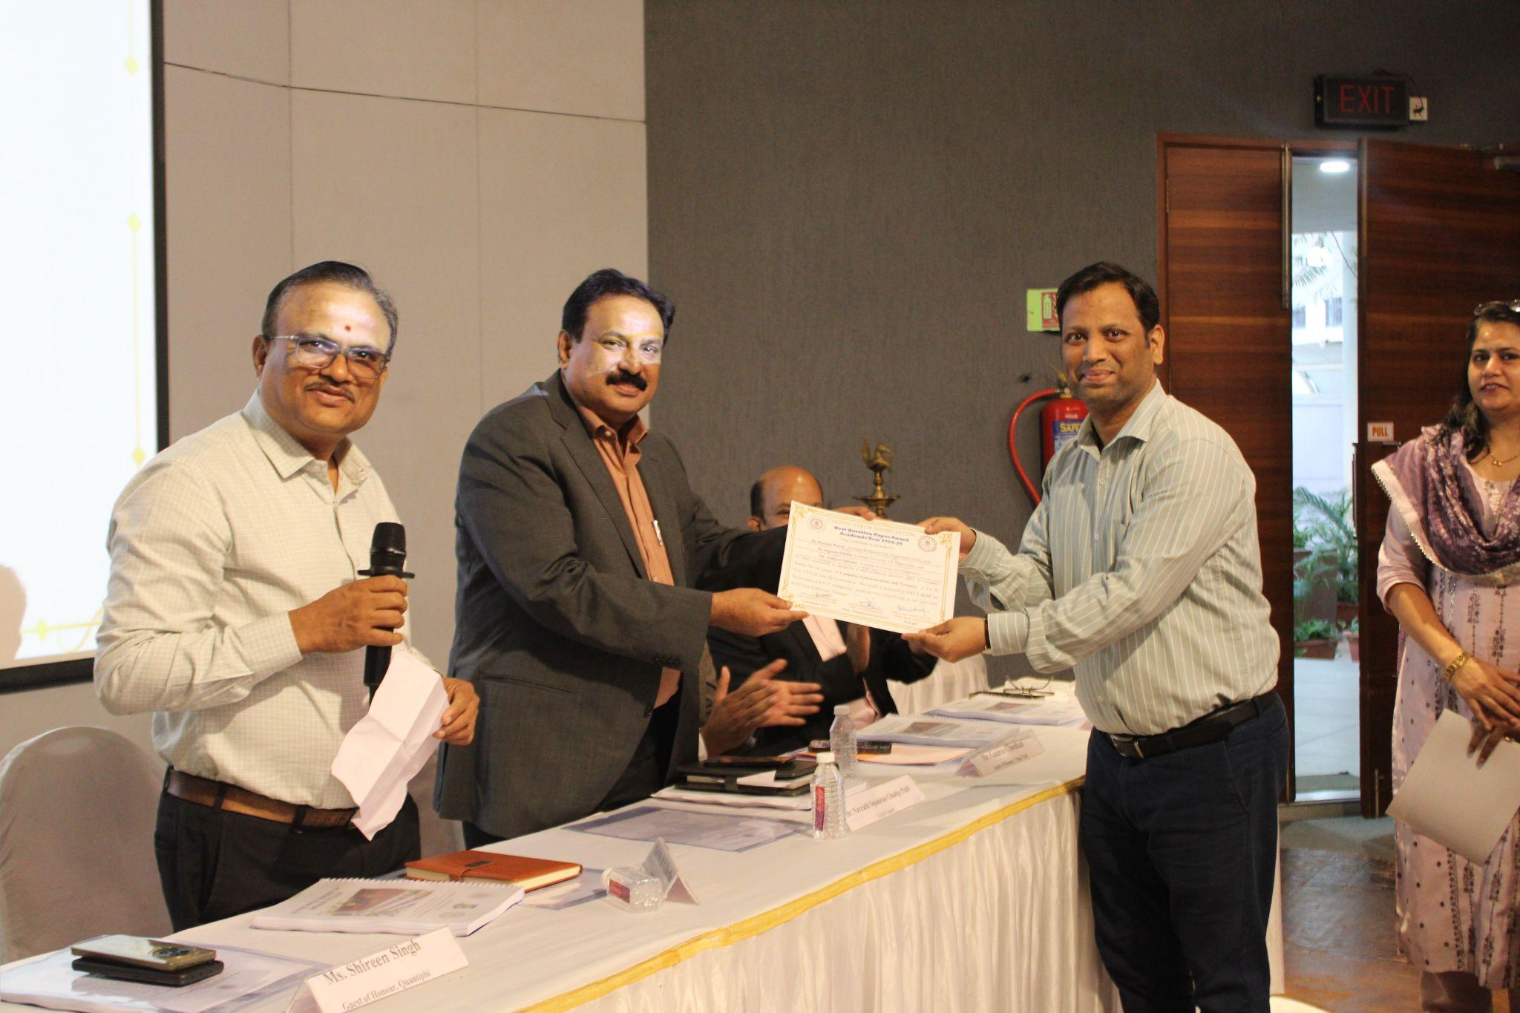
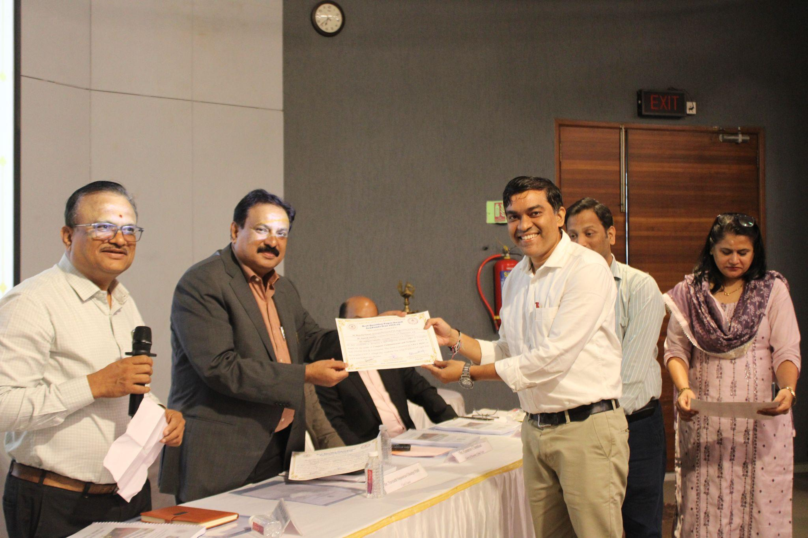

Students Achievements
Sr. No | Event Details | Name | Name of the Organization/agency/international agencies from where award has been received | Class
Department of Computer Engineering (July 2025- June 2026)
FE
1 | Shri Ram Investment Competition (First Position) | Nivaan Shah | D-Street, Sri Ram College of Commerce | FE Comp
SE
1 | International Collegiate Programming Contest, Asia Amritapuri Regionalist | Raj Kale, Abhimanyu Kadhane, Adityavardhan Iyengar | ICPC Foundation | SE Comp
 |  |  |  | SE Comp
2 | National Case Study Competition at Sri Ram College of Commerce (First Position) | Rudraksh Shah | Sri Ram College of Commerce | SE Comp
3 | Recursion 7.0 (2nd runner up) | Amit Gandhi | Ragiv Gandhi Institute of Technology (RGIT) | SE Comp
3 | Recursion 7.0 (2nd runner up) | Stavan Ketan Desai | Ragiv Gandhi Institute of Technology (RGIT) | SE Comp
3 | Recursion 7.0 (2nd runner up) | Piyush Fatnani | Ragiv Gandhi Institute of Technology (RGIT) | SE Comp
3 | Recursion 7.0 (2nd runner up) | Stavan Ketan Desai | Ragiv Gandhi Institute of Technology (RGIT) | SE Comp
3 | Recursion 7.0 (2nd runner up) | Yash Dharamshi | Ragiv Gandhi Institute of Technology (RGIT) | SE Comp
4 | Equinox 26, KKWIEER (First Position) | Nitin Gaikwad | K.K Wagh Institute Of Engineering Education and Research | SE Comp
5 | Spectrum Hackathon | Vidhi Shah, Heli Shah, Dhyani Sanghvi, Mahi Savla | Shri Bhagubhai Mafatlal Polytechnic and College of Engineering | SE Comp
6 | National Science Day, VJTI | Nirupam Gupta | Veermata Jijabai Technological Institute | SE Comp
7 | Business Prodigys Ltd | Param Vikram Rajgor | Business Prodigys Limited | SE Comp
7 | Runner Up at Enigma Hackathon | Khadayate Mayank Prafulla | SIES Graduate School of Technology | SE Comp
7 | Winner At Ignite26 Project Pitching Competition | Khadayate Mayank Prafulla | Kk Wagh college of engineering Nashik | SE Comp
7 | Runner Up at Enigma Hackathon | Khadayate Mayank Prafulla | SIES Graduate School of Technology | SE Comp
8 | Stratopia VJTI | Devraj Sundrani | E-Cell VJTI | SE Comp
9 | Stratos | Devraj Sundrani | SPCG E-Cell SPIT | SE Comp
TE
1 | EY Techathon 6.0 Winner | Soham Ghorpade | Ernst & Young (EY) | TE Comp
1 | EY Techathon 6.0 Winner | Dikshant Karande | Ernst & Young (EY) | TE Comp
1 | EY Techathon 6.0 Winner | Dwayne Fernandes | Ernst & Young (EY) | TE Comp
2 | EY Techathon | Swain Dias, Dwyane Fernandes, Soham Ghorpade, Dikshant Karande | Ernst & Young | TE Comp
3 | GenAi Exchange Hackathon Third Runner Up | Daksh Chetan Jain | Google Cloud | TE Comp
4 | IIT Bombay Techfest AI Eduthon Winner | Daksh Jain | Cograd | TE Comp
5 | Marketing Showdown held at Shailesh J Mehta School of Management ,IIT Bombay | Soham Kher | Shailesh J Mehta School of Management , IIT Bombay | TE Comp
6 | India Innovates 2k26 | Sahil Gupta | MCD (Muncipal Co-operation of Delhi) | TE Comp
6 | India Innovates 2k26 | Vinayak Yadav | MCD (Muncipal Co-operation of Delhi) | TE Comp
6 | India Innovates 2k26 | Nikhil Kamal Vishwakarma | MCD (Muncipal Co-operation of Delhi) | TE Comp
6 | India Innovates 2k26 | Yateen Vaviya | MCD (Muncipal Co-operation of Delhi) | TE Comp
6 | India Innovates 2k26 | Vishwajit Sarnobat | MCD (Muncipal Co-operation of Delhi) | TE Comp
6 | India Innovates 2k26 | Yessica Sule | MCD (Muncipal Co-operation of Delhi) | TE Comp
7 | Shark-A-Thon | Madhav Shah , Apurva Khangal | ABIT | TE Comp
8 | Certificate of Appreciation for Critical Security Vulnerability Disclosure | Madhav Shah | GeeksForGeeks | TE Comp
9 | TSEC Hackathon - Hackathon Win First Place | Madhav Shah | TSEC | TE Comp
10 | Adappt 4.0 Hackathon Winner - 1st Place | Madhav Shah | NMIMS | TE Comp
11 | Zoho Bug Bounty Recognition (Security Vulnerability Disclosure) - Hall of Fame | Madhav Shah | Zoho | TE Comp
12 | Chaitanya case competition IIM Indore | Sanjana Pillai (Team Members- Aditya Khabiya, Harsh Malpani) | IIM INDORE | TE Comp
13 | Ethereum Bug Bounty Recognition (Hall of Fame) | Madhav Shah | Ethereum Foundation | TE Comp
14 | Hackathon 2026 | Uzmah Yusuf Shaikh | Divine Educational Solutions | TE Comp
15 | Odoo x SPIT Hackathon | Aayush Shah | Odoo | TE Comp
16 | HackFusion International Hackathon Winner | Vir Bhalani, Daksh Jain, Vishwesh Nair, Jill Mistry | IEEE SPIT and IEEE UMIT | TE Comp
17 | S.P.I.T. Hackathon Domain Winner | Vir Bhalani, Oren Coelho, Piyush Rathi, Daksh Jain | CSI SPIT | TE Comp
18 | The Marketing Showdown - Case Study Competition by Shailesh J Mehta School of Management, IIT Bombay | Soham Kher | Shailesh J Mehta School of Management, IIT Bombay | TE Comp
19 | Winner at BITS Hyderabad | Aniruddh Iyer | BITS Hyderabad | TE Comp
20 | The Marketing Showdown - Shailesh J Mehta School of Management, IIT Bombay | Aniruddh Iyer | shailesh J Mehta School of Management, IIT Bombay | TE Comp
21 | Break The case, case study winner of BITS Hyderabad | Aniruddh Iyer | BITS Hyderabad | TE Comp
22 | Winner in Emotional Intellgience | Daksh Jain | NMIMS-Mukesh Patel School of technology management and engineering | TE Comp
22 | Winner in Emotional Intellgience | Vinisha Bhagwani |  | TE Comp
23 | First Place - Chaitanya Case Study Competition | Aditya Khabiya | Indian Institute of Management, Indore | TE Comp
24 | National Winner - EY Techathon | Swain Dias, Dwyane Fernandes, Soham Ghorpade, Dikshant Karande | Ernst & Young | TE Comp
25 | Nexos AI - Code Kong (2nd Place) | Daksh Jain | Nexos AI | TE Comp
26 | winner in emotional intelligence | vinisha bhagwani | nmims | TE Comp
27 | hackathon winner | vinisha bhagwani | Nexos AI-Code Kong | TE Comp
28 | National Finalist at Prodyssey , IIM Indore | Aniruddh Iyer | IIM INDORE | TE Comp
29 | National Finalist and Special Mention for third runner-up, Imperium , IIM Indore | Aniruddh Iyer | IIM INDORE | TE Comp
30 | Vishleshan Runner-up IIM Raipur Case Study | Aniruddh Iyer | IIM Raipur | TE Comp
31 | AIML Domain Winner, SE Hackathon | Atharva Deokar, Saur Deshmukh, Aniket Atole | CSI - SPIT | TE Comp
32 | Accenture - Hack the Future | Atharva Deokar, Asmiya Sayyad | Accenture & GeeksforGeeks | TE Comp
33 | Imperium Strategy Case Study Competition - IIM Indore | Soham Kher | IIM Indore | TE Comp
34 | Hackathon APOGEE Pluss Advance Technology | Soham Budhewar | BITS Pillani | TE Comp
34 | Hackathon APOGEE Pluss Advance Technology | Pratik Jambhule | BITS Pillani | TE Comp
34 | Hackathon APOGEE Pluss Advance Technology | Kartik Kharat | BITS Pillani | TE Comp
BE
1 | Optimization Theory and and Algorithms | Soorya Sivaramakrishnan | NPTEL | BE
2 | AIR-97 in GATE DA, with a Score of 816 | Atharva Jagtap | IIT Guwahati | BE
3 | HSBC Hackathon | Sanjeev Ratnani | HSBC Software Development India | BE
4 | Tech Extreme 1st prize | Sujal Samar Das | Ramaniranjan jhunjhunwala college | BE
5 | Nomura’s KakushIN Hackathon | Tanush Salian and Suryansh Singh | Nomura | BE
6 | HSBC CTF Hackathon 2025 | Muskan Sharma | HSBC Software Development India, IITB Trust Lab | BE

